A topographic map, simply put, is a two-dimensional representation of a portion of the three-dimensional surface of the earth. Topography is the shape of the land surface, and topographic maps exist to represent the land surface. Topographic maps are tools used in geologic studies because they show the configuration of the earth’s surface. Cartographers solve the problem of representing the three-dimensional land surface on a flat piece of paper by using contour lines, thus horizontal distances and vertical elevations can both be measured from a topographic map.

**General Information**The terms below indicate what information is contained on a topographic map, and where it can be found.

**Map Scale:** Maps come in a variety of scales, covering areas ranging from the entire earth to a city block (or less).

**Vertical Scale (contour interval):** All maps have a horizontal scale. Topographic maps also have a vertical scale to allow the determination of a point in three dimensional space.

**Contour Lines:** Contour lines are used to determine elevations and are lines on a map that are produced from connecting points of equal elevation (elevation refers to height in feet, or meters, above sea level).

*The following are general characteristics of contour lines:*

**1**. Contour lines do not cross each other, divide or split.   
**2**. Closely spaced contour lines represent steep slopes, conversely, contour lines that are spaced far apart represent gentle slopes.   
**3**. Contour lines trend up valleys and form a "V" or a "U" where they cross a stream.

On most topographic maps, index contour lines are generally darker and are marked with their elevations. Lighter contour lines do not have elevations, but can be determined by counting up or down from the nearest index contour line and multiplying by the contour interval. The contour interval is stated on every topographic map and is usually located below the scale.

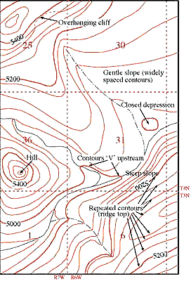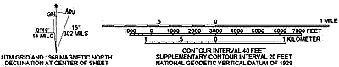

Source: http://imnh.isu.edu/digitalatlas/geog/basics/topo.htm